TUM Open Infra Platform

Developer Documentation

Content

About this Document 3

Name conventions 3

Getting started 3

Needed Software 3

Long time support 5

Clone the repository 5

Compiling 5

Creating a Visual Studio 2015 x64 Solution 5

Prebuild early bindings 13

After compiling 14

Workflow: How to commit code? 15

Contacts 19

The Developers 19

Website 19

TUM Open Infra Platform 21

Use Cases 21

Use Case #1: Viewing alignment, road and terrain data 21

Use Case #2: Import/Export LandXML, OKSTRA and IFC Alignment data 21

Use Case #3: Create new alignment and terrain data 21

Features 21

Background knowledge 22

Alignment 22

Horizontal Alignment 22

LandXML 23

File format issues 23

Clothoid 24

Clothoid implementation 24

Vertical alignment 27

Computation of vertical alignments (parabolas) 27

Vertical alignment that starts with a parabola 28

IFC Alignment 28

RoadXML 29

Tools 30

JSDAI 30

AutoCAD Civil 3D 2014 31

Code Guidelines 32

Syntax #1 32

Ident style #1 32

Comments #1 33

Comments #2 33

Tags 33

Includes #1 33

Includes #2 33

CMake 34

Code Architecture 34

Code in Detail 34

IFC Eearly Binding Meta Template Library (ifcEMT) 34

Testing 36

Testdata 36

Unit Testing 38

IFC Alignment Common Mistakes 38

Check #1 38

Check #2 38

Check #3 39

Check #4 39

# About this Document

This short guide shows you how to compile the project TUM Open Infra Platform.

***Warning:*** This document is only snapshot of the current state and may be become obsolete in the future.

# Name conventions

The release title of the software is TUM Open Infra Platform. Sometimes it is only called Open Infra Platform or more shortly OIP.

# Getting started

## Required Software

To be able to build Open Infra Platform on your machine you need some tools and third party libraries.

### Tools

1. TortoiseHg (Version 4.5.2) available at <https://tortoisehg.bitbucket.io/download/index.html>



* + Should already be installed, otherwise you can’t clone the repository!

1. CMake (Version 3.13 or higher) available at <https://cmake.org/download/> which is used to create a Visual Studio solution.
2. Visual Studio 14 2015 or Visual Studio 15 2017, Visual Studio 16 2019 doesn´t work. Available at <https://www.visualstudio.com/de/downloads/> with Windows 10 SDK (10.0.16299.0).
3. Python 3 available https://www.python.org/downloads/release/python-373/ or via the Anaconda distribution available at <https://www.anaconda.com/download/> to execute the python scripts for versioning etc.
   * Make sure to add the python executable to your PATH environment variable.
   * Make sure to install the x64 version.
4. Qt 5.12 (<https://www.qt.io/download>)
   * Go for the Source Version
   * Important that you install it under C:/Qt
   * Make sure to have there components installed

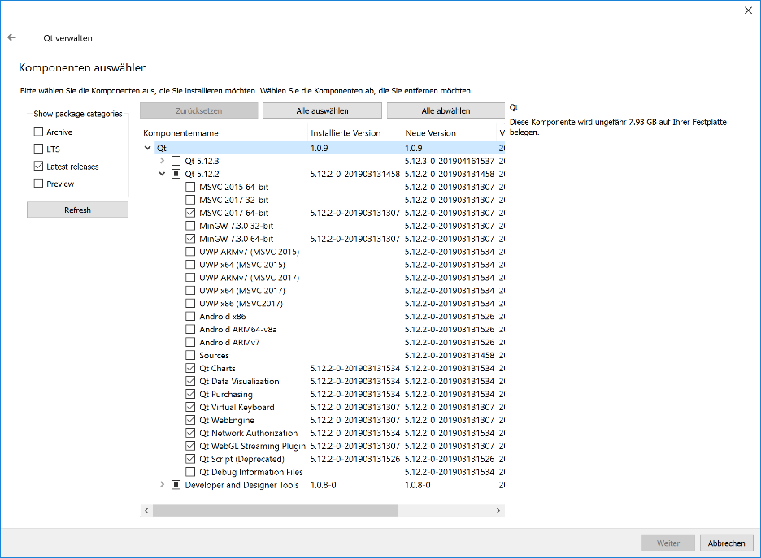

## Clone the repository

The source code of Open Infra Platform is managed using the hg (aka Mercurial) version control system (get TortoiseHg from <https://tortoisehg.bitbucket.io/download/index.html> ). To obtain the source code follow the listed instructions:

### Via Console

1. Open a console window.
2. Switch to directory where you want to clone the repository.
3. Type hg clone <https://bitbucket.org/tumcms/openinfraplatform>

into a console window. If you are not familiar with the windows command line, there is also a visual way.

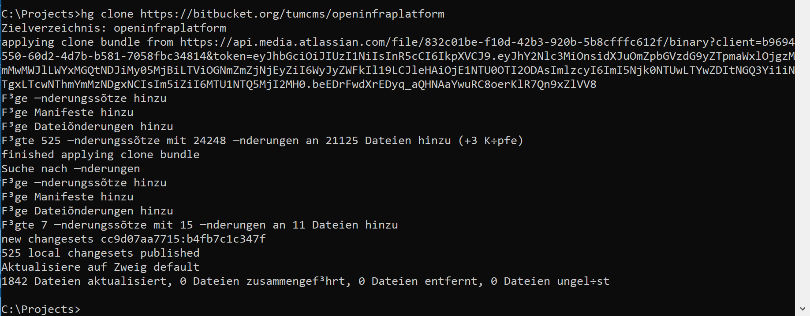

### With GUI

1. Right click in the explorer in the directory where you want to clone the repository.
2. Click HG Workbench->Clone… or directly Clone… in the TortoiseHg explorer tool.

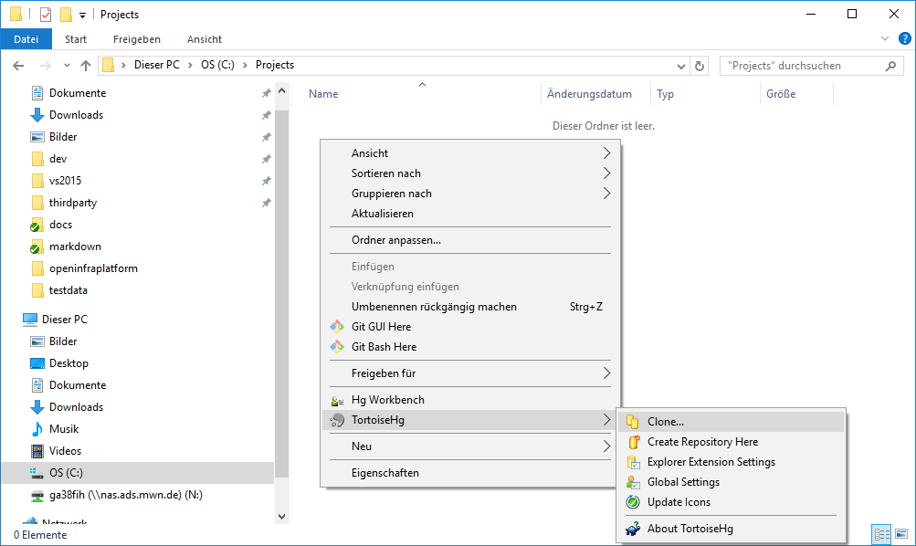

1. Now enter <https://bitbucket.org/tumcms/openinfraplatform> as source and press clone again.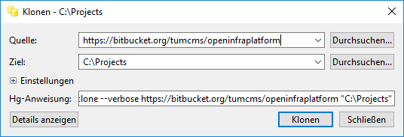

In both ways, after cloning and opening up the HG Workbench you should see something like this: 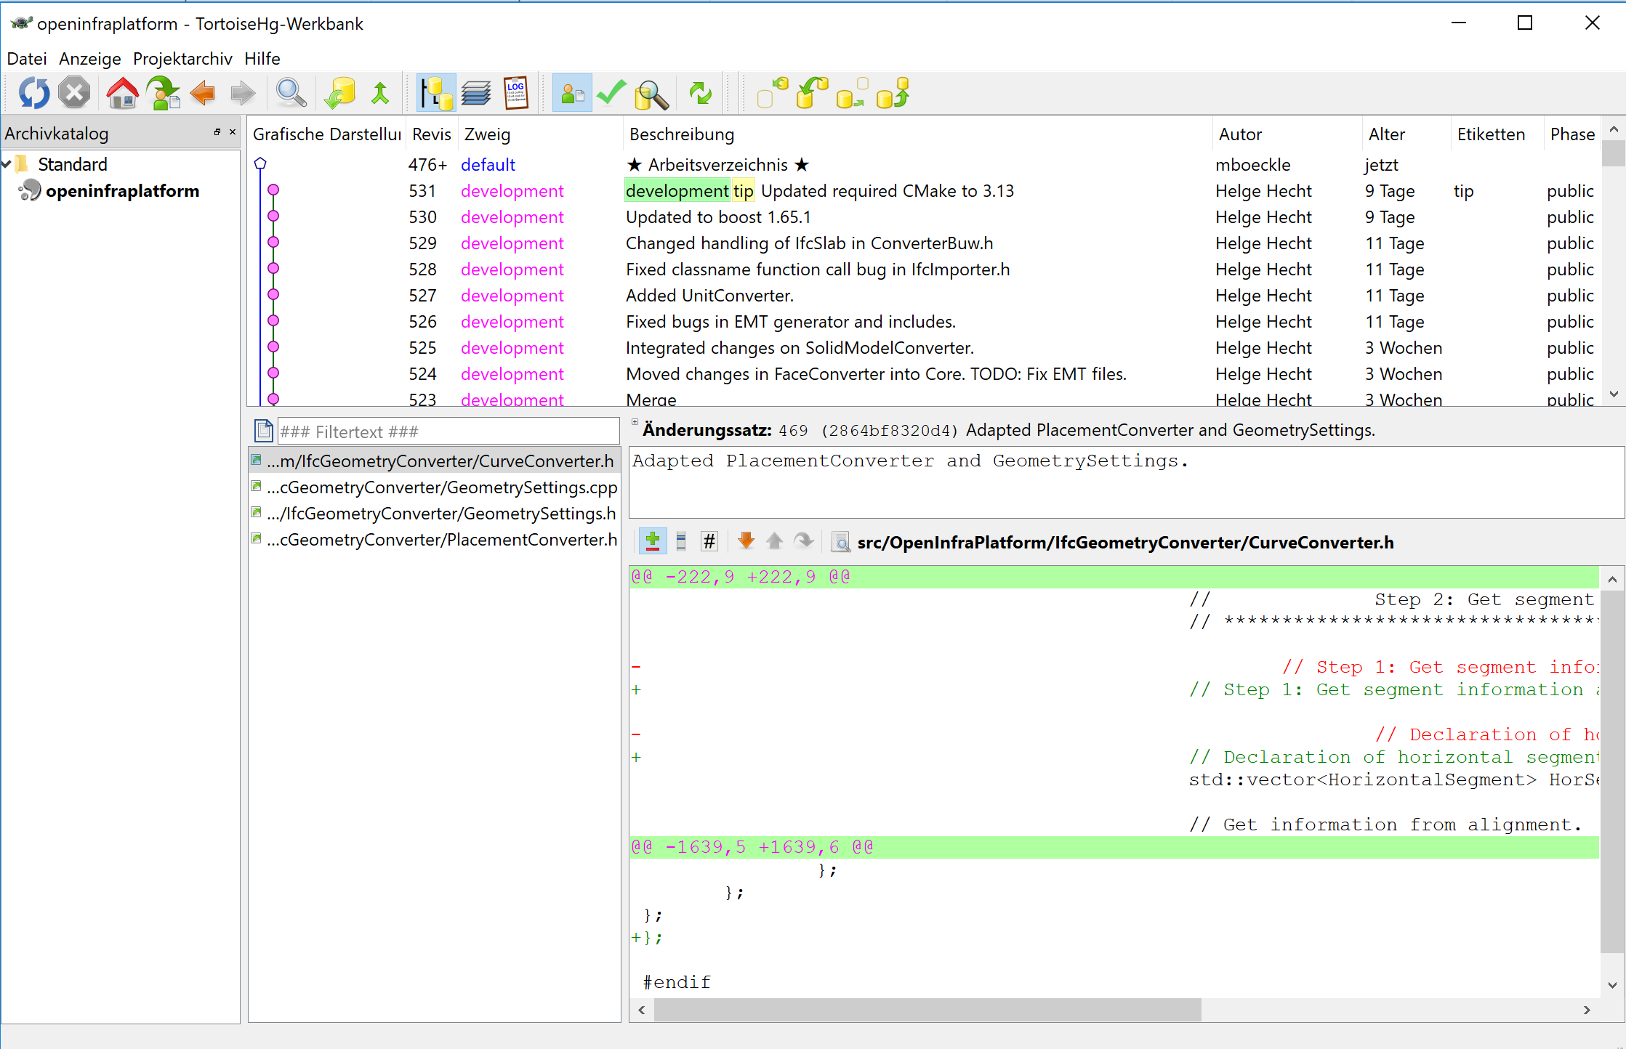

Contact [Stefan.markic@tum.de](mailto:Stefan.markic@tum.de) or [helge.hecht@tum.de](mailto:helge.hecht@tum.de) to get test data.

### Third Party Libraries (Required)

Create a folder named thirdparty in C:\ and install the following tools and libraries:

1. Boost 1.65.1 (<https://sourceforge.net/projects/boost/files/boost-binaries/>). Please install to “C:\thirdparty\vs2015\x64\boost_1_65_1”. It can be useful to add this path into the environment variables.

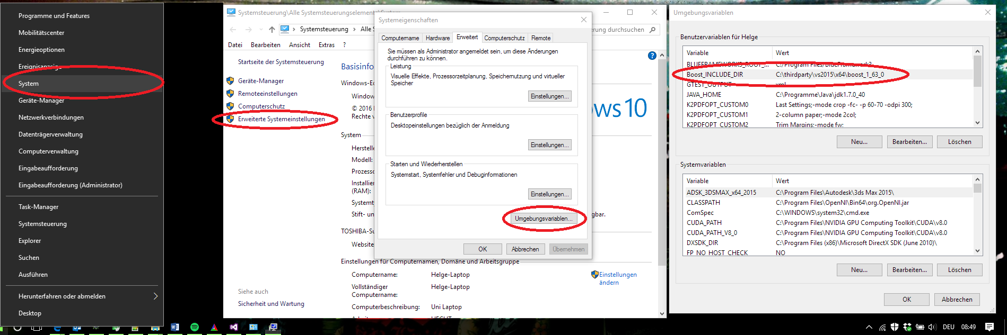

1. Eigen 3.3.7 (<http://eigen.tuxfamily.org/index.php?title=Main_Page>). Please download and than install/unzip the .zip-file to “C:\thirdparty\vs2015\x64\Eigen_3.3.7”. Since Eigen is a header only library, unzipping the contents of the downloaded zip serves as full installation. There are no setups involved.
2. BlueFramework (<https://bitbucket.org/tumcms/blueframework/downloads/BlueFramework-3.1.1.94-win64.msi> ). You can also build the BlueFramework yourself (not recommended for most users). Similar to boost, it is useful to set the “BLUEFRAMEWORK_ROOT_DIR” environment variable to the location where your BlueFramework is installed (“C:\Program Files\BlueFramework”).

### Third Party Libraries (Deprecated/Optional)

1. Python 3.7.3 **x64**: Add python.exe to Path. (Note: It is very important that an x64 Version of Python is used instead of an x86 – otherwise the compilation will not work. Please do not use any other version of python because this is untested – also install this python version before you build the boost libraries, if you build them yourself) (<https://www.python.org/downloads/>) 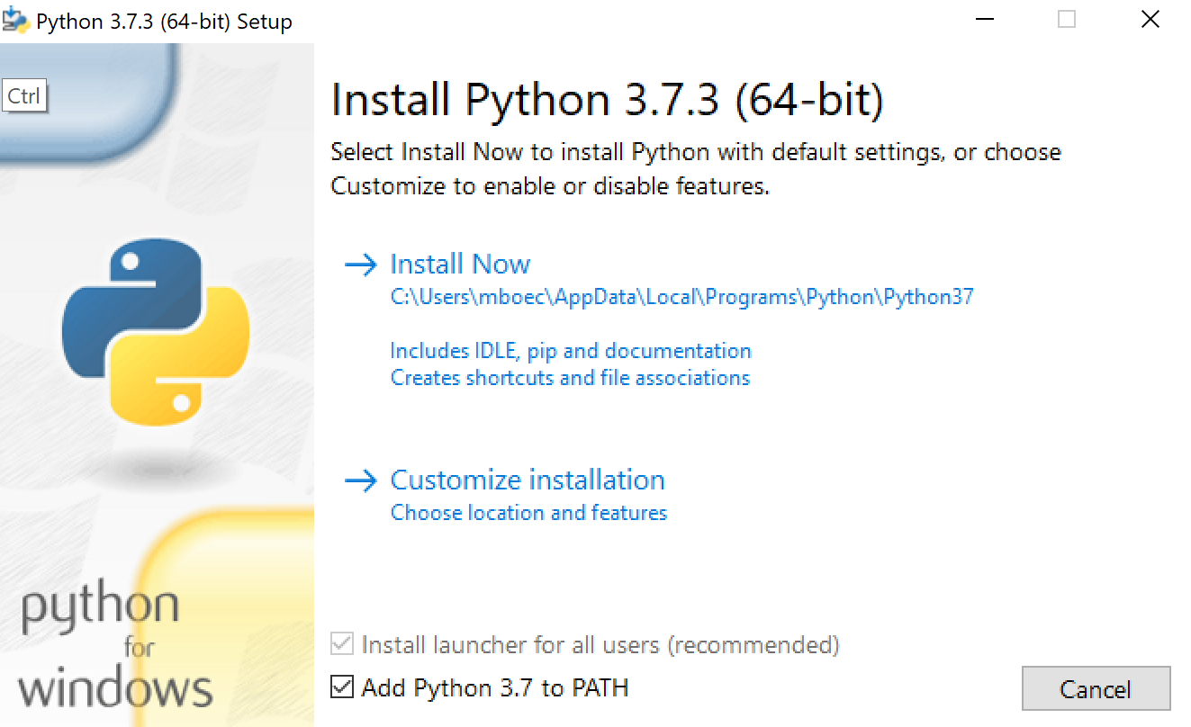

## Compiling

### Creating the Solution

Open CMake and set the text of the “Where is the source code:” text box to path where the source code of the OpenInfraPlatform2 repository is located. Set the “Where to build the binaries:” directory to where you want to build the project (this path does not need to exist).

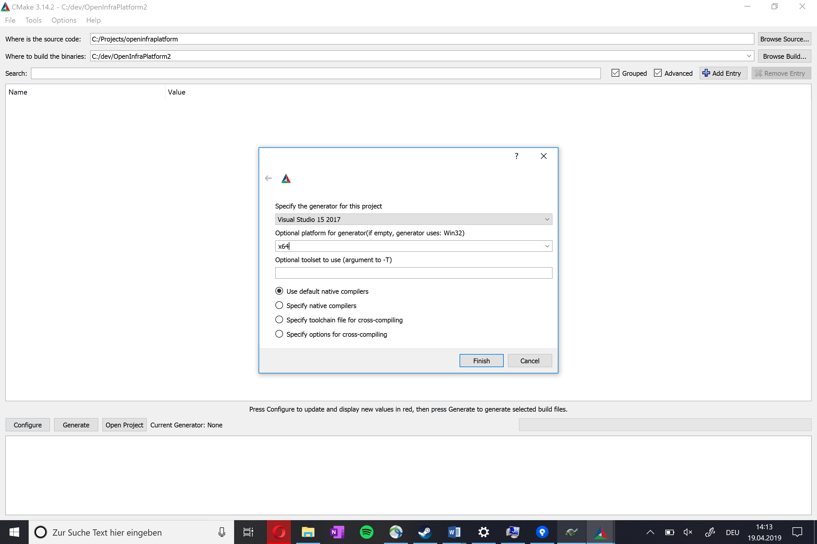

Then click the configure button. Then select Visual Studio 15 2017 as the version, set the Optional platform to x64 and choose the default native compilers. Then hit finish.

Then CMake should look for the first libraries. After some time, it should stop and look similar to this:

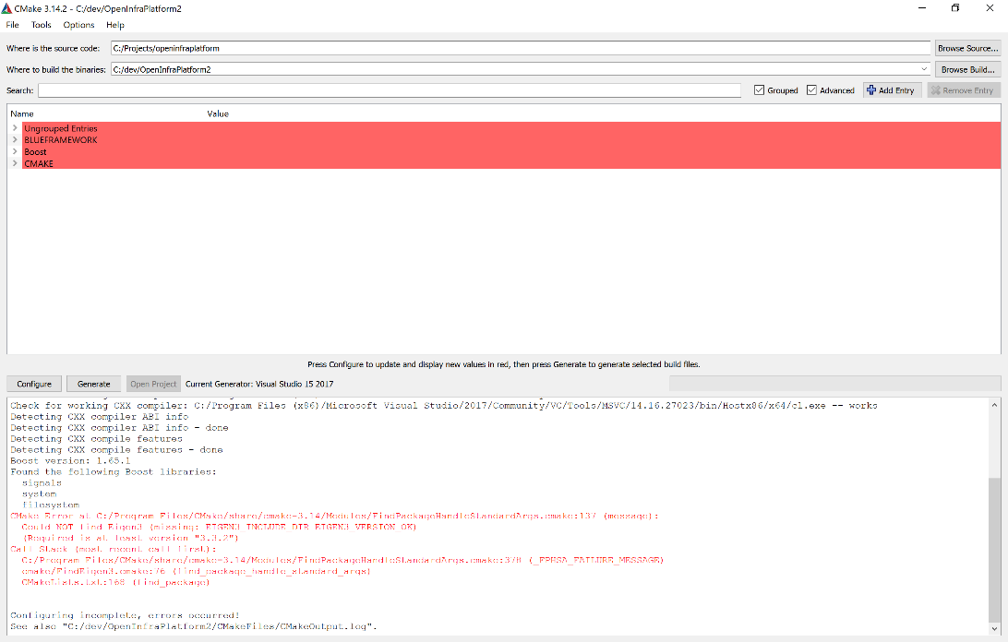

Depending on the environment variables etc., CMake will find some libraries and programs immediately while some will require some help to locate.w

#### Finding Boost

If you have set the Boost_INCLUDE_DIR to the boost root dir in your environment variables, it should automatically detect the libraries. Make sure to hafe the BOOST_ROOT set to the Path where you have installed boost and the Boost_INCLUDE_DIR to the same path.

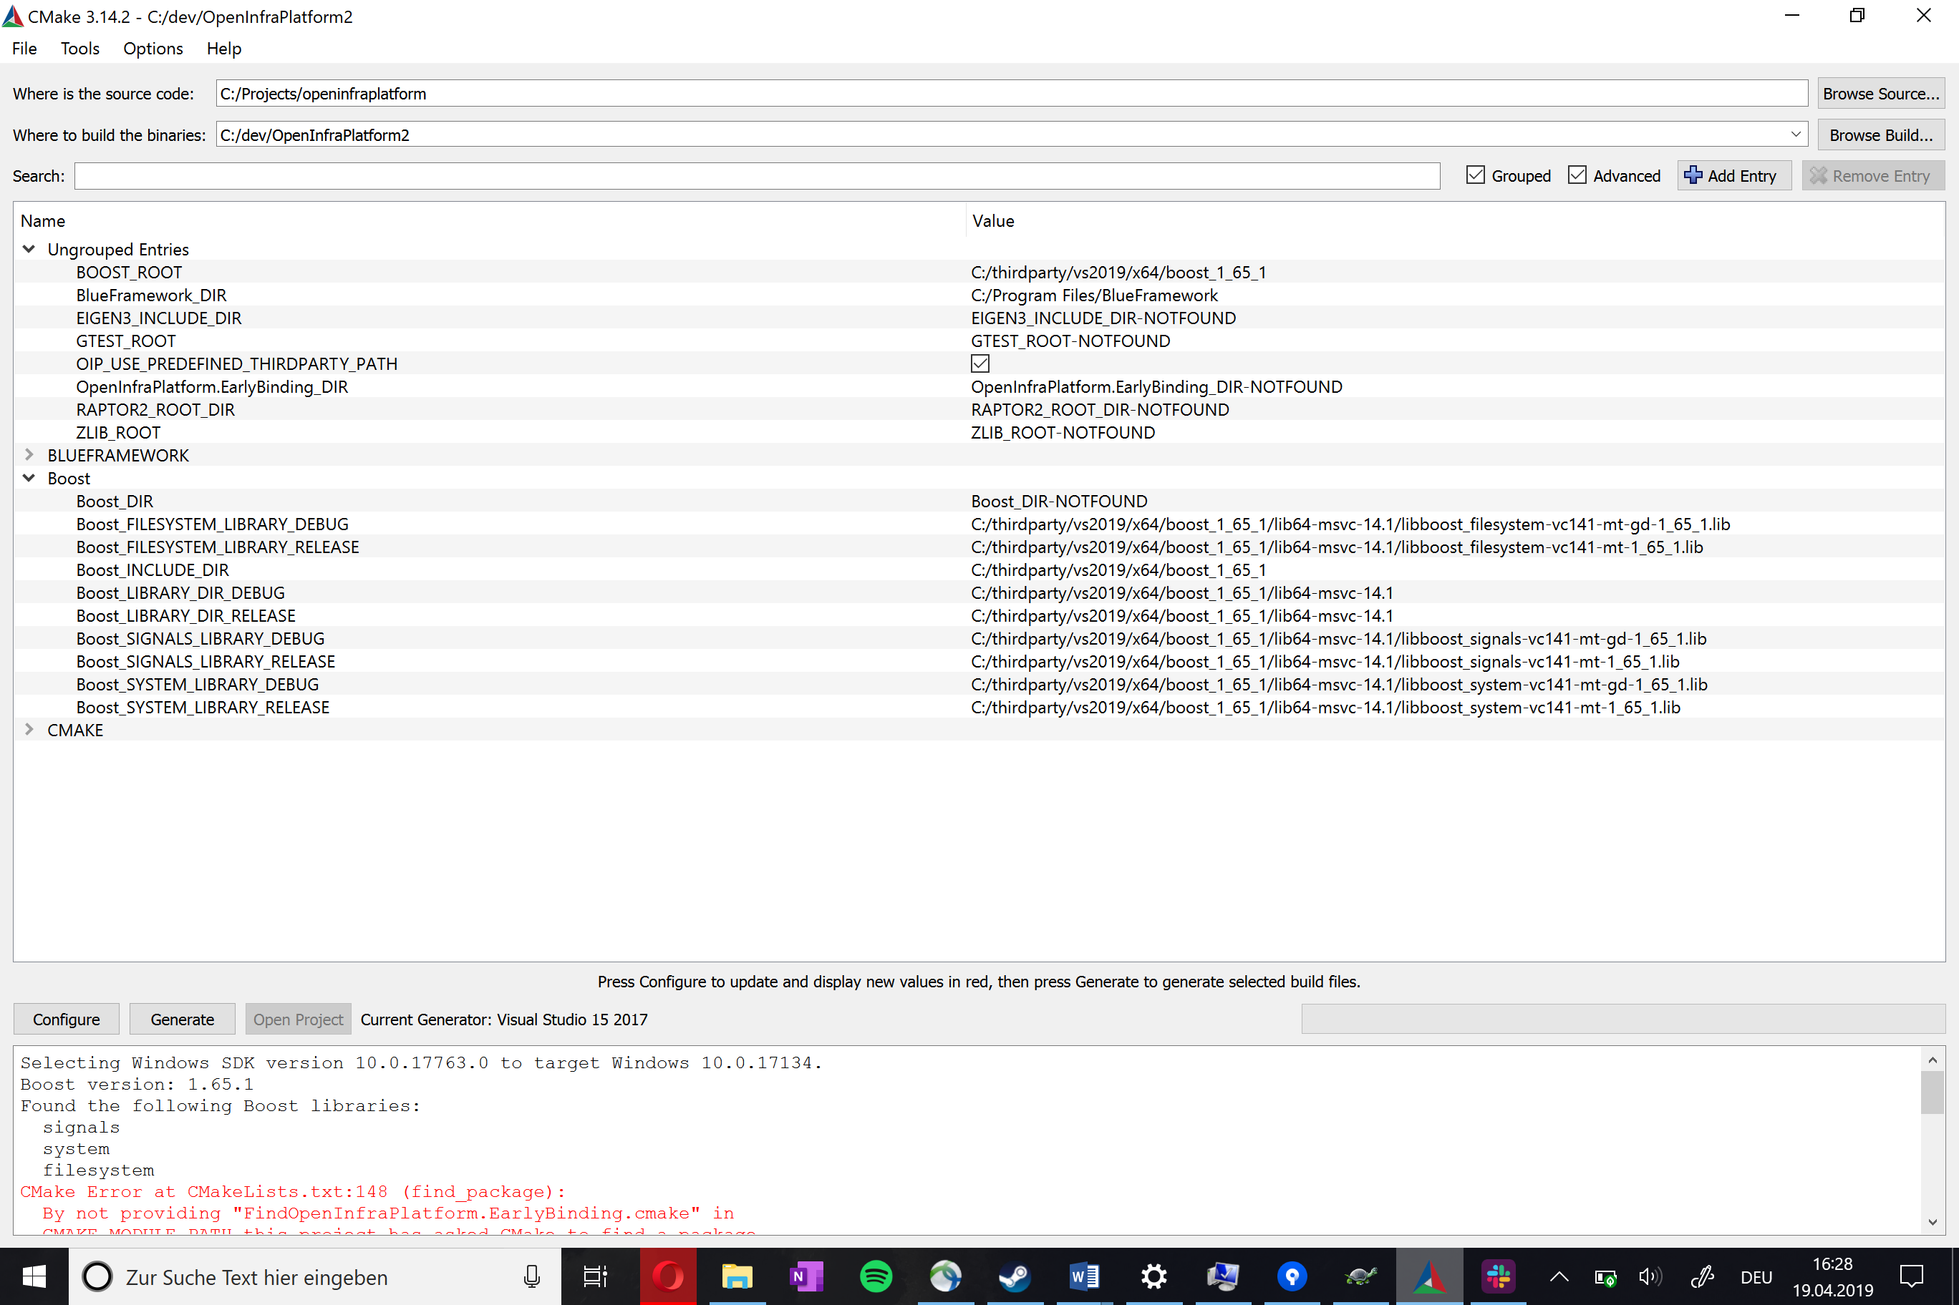

#### Finding Eigen

To find eigen, set the EIGEN3_INCLUDE_DIR path to the root path of your Eigen installation. Just click the “Browse” button next to the path and navigate to your installation directory. Then select this folder and click the configure button again.

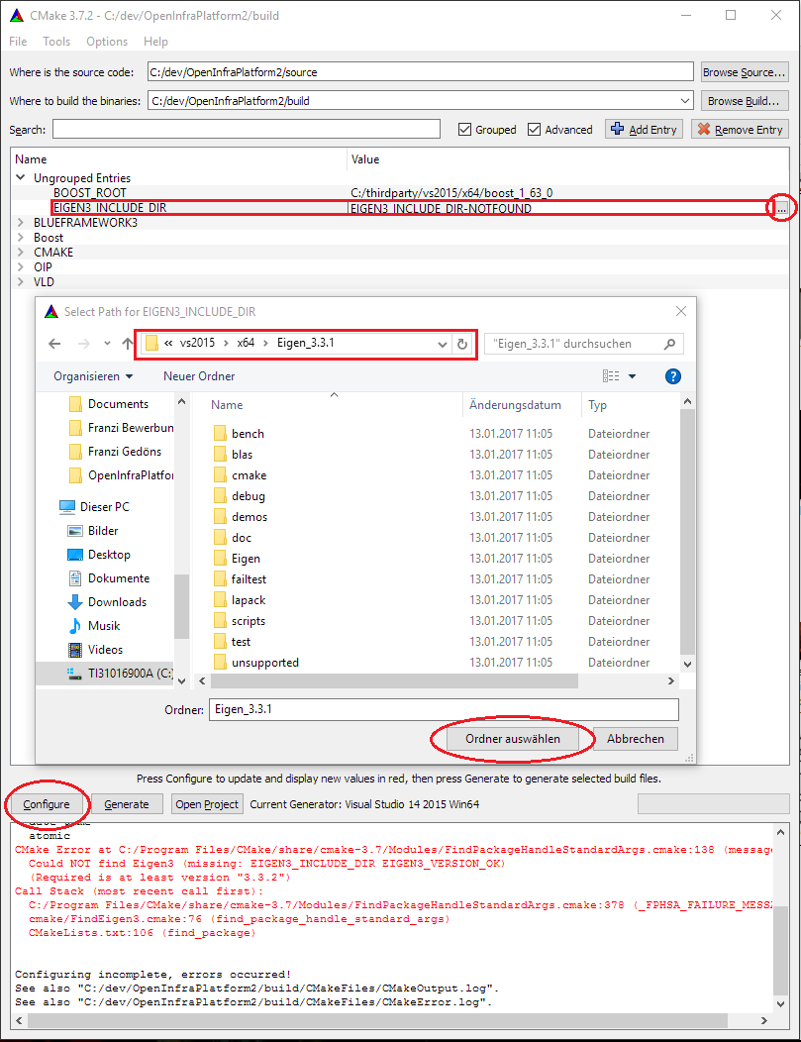

After that, there should be a line in the log saying that Eigen3 has been found.

#### Finding Qt

To find Qt fast, it is best the add the entry “CMAKE_PREFIX_PATH” with the path to “C:\Qt\Qt5.8.0\5.8\msvc2015_64\lib\cmake” to either the environment variables or in the CMake GUI. This can be done by clicking the “Add Entry” button in the GUI and then selecting PATH as Type and navigating to the path in the value field. CMake should then be able to locate the Qt libraries automatically.

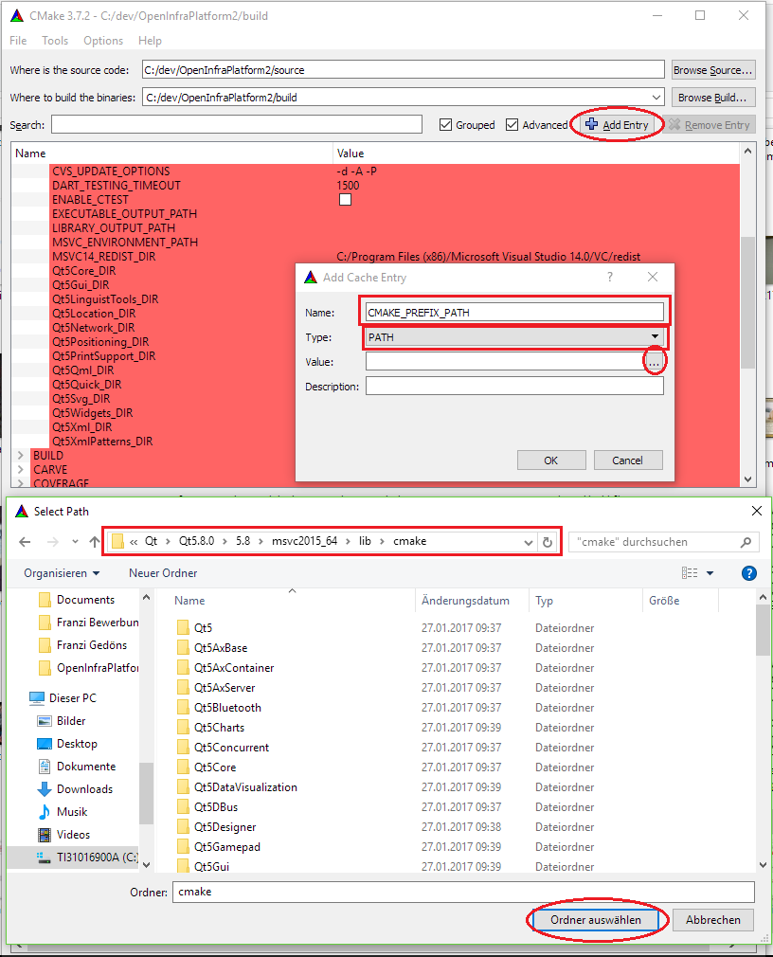

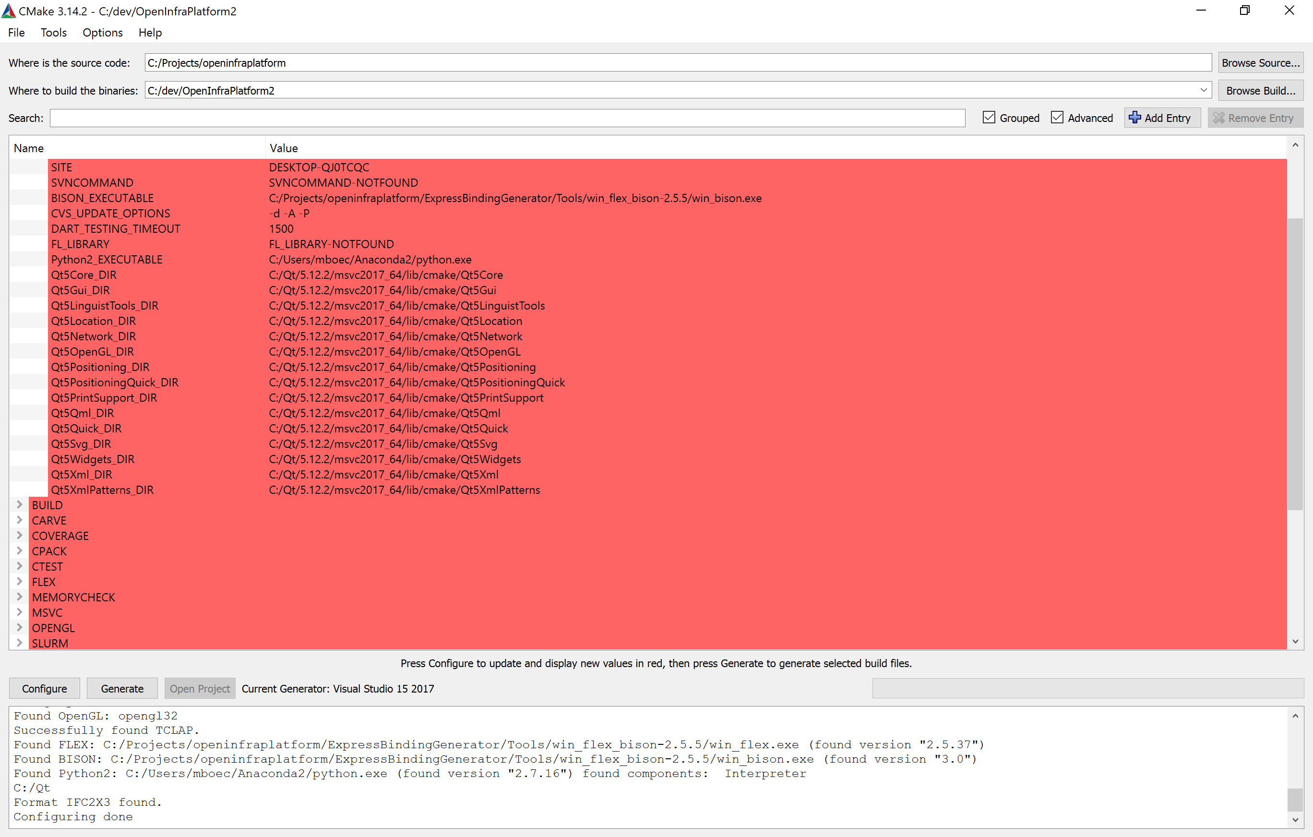

If the Qt-Files don´t show, you have to go to CMake and put in the CMAKE_PREFIXE_PATH again.

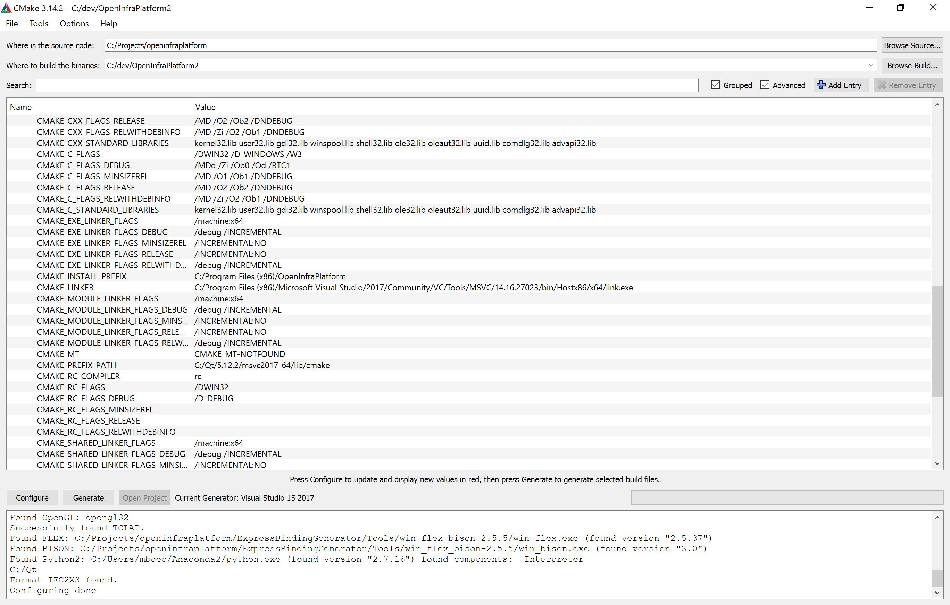

#### Finding the rest

All other libraries should be found automatically, like Python and VLD etc.

### Compiling the Solution

When opening the generated solution by clicking OpenProject in the CMake GUI the first time the ALL_BUILD target is selected.

## After compiling

After successful compiling you can run the program. In the VS GUI create Commands.GenerateEarlyBinding, OpenInfraPlatform.ExpressBindingGenerator and finaly Commands.GenerateEarlyBinding. If you´ve done that you should be able to create the OpenInfraPlatform.Core and you´re good to go.

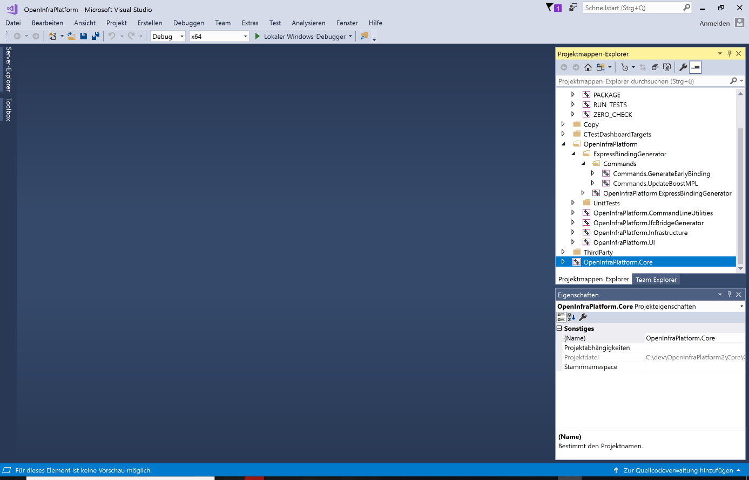

## Workflow: How to commit code?

Create a fork of the OpenInfraPlatform project. This needs to be done, because of the access management policy. You are only allowed to read from the repository not to write to it. For that reason you have to make an own fork. Your forked repository should be private.

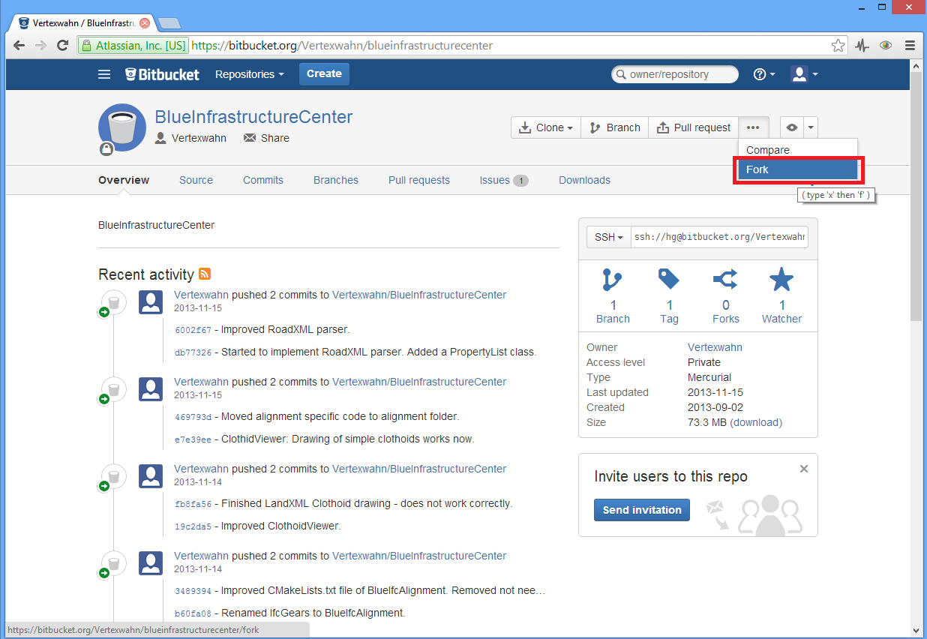

You can name your fork as you wish, but a good name of the fork is a word that describes what you are working on in this fork.

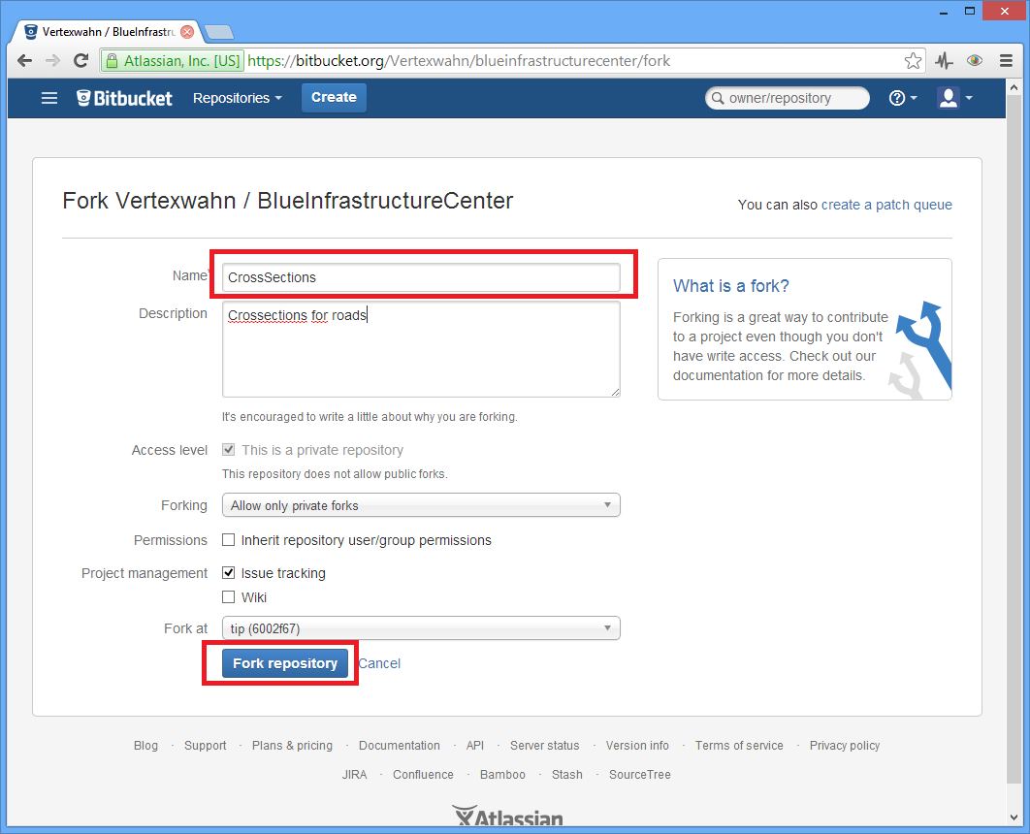

After creating the fork you should clone your own fork. For instance clone it by typing something like “hg clone <https://Vertexwahn@bitbucket.org/Vertexwahn/crosssections>” to your console.

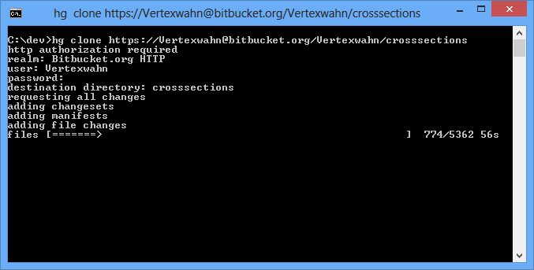

After cloning the forked repository you should only make changes to your forked repository. You can commit and push changes to your forked repository. If you are done with your task you can make a “Pull request” to the original OpenInfraPlatform repository.

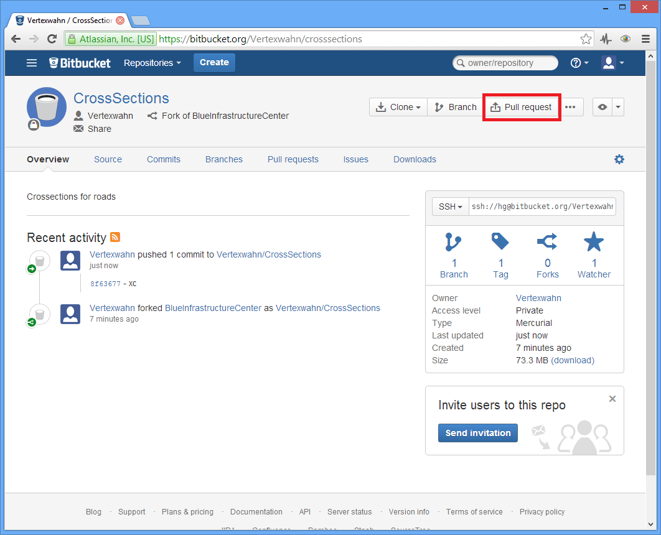

The pull request will be sent to the project manager:

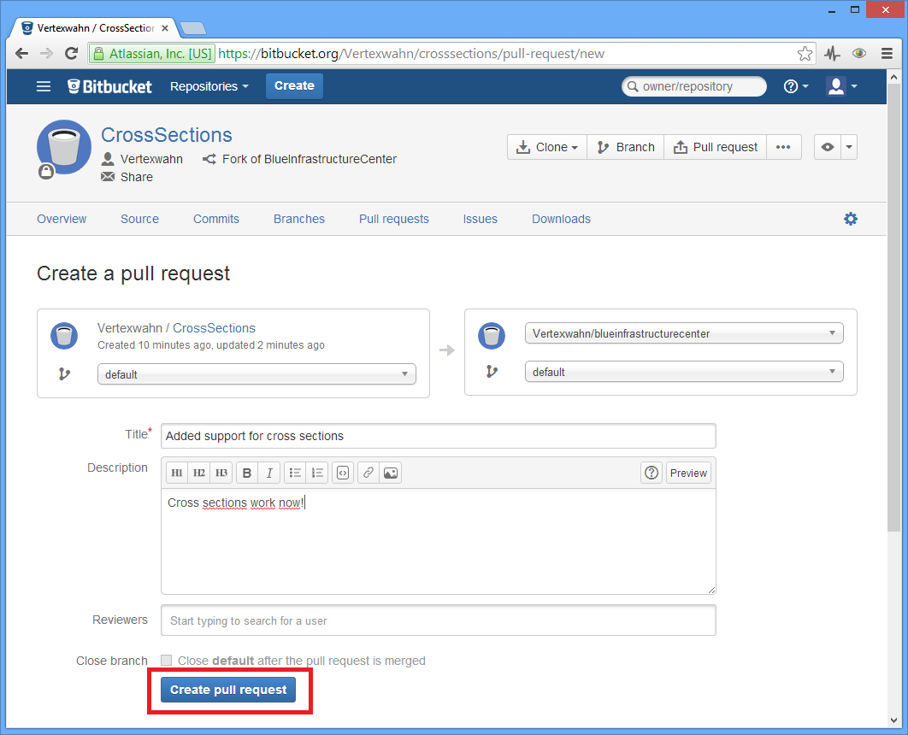

Then a code review will take place. The project manager will inform you what needs to be changed before the pull request is accepted. Once the code review is finished your changes will be applied to the original OpenInfraPlatform.

Sometimes there can be changes in the original repository, that you want also have in your forked repository. To get the change you have to Sync your forked repository by clicking “Sync now”.

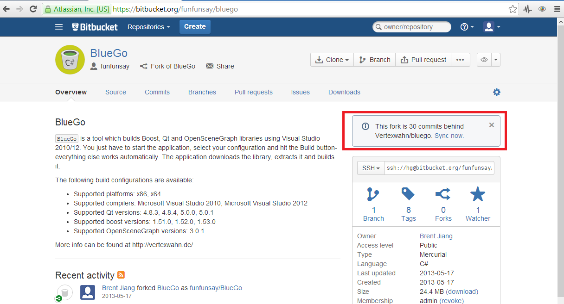

This workflow helps the project manager to see what changes have been introduced in the code base. Also it is possible via BitBucket to add comment to your changes.

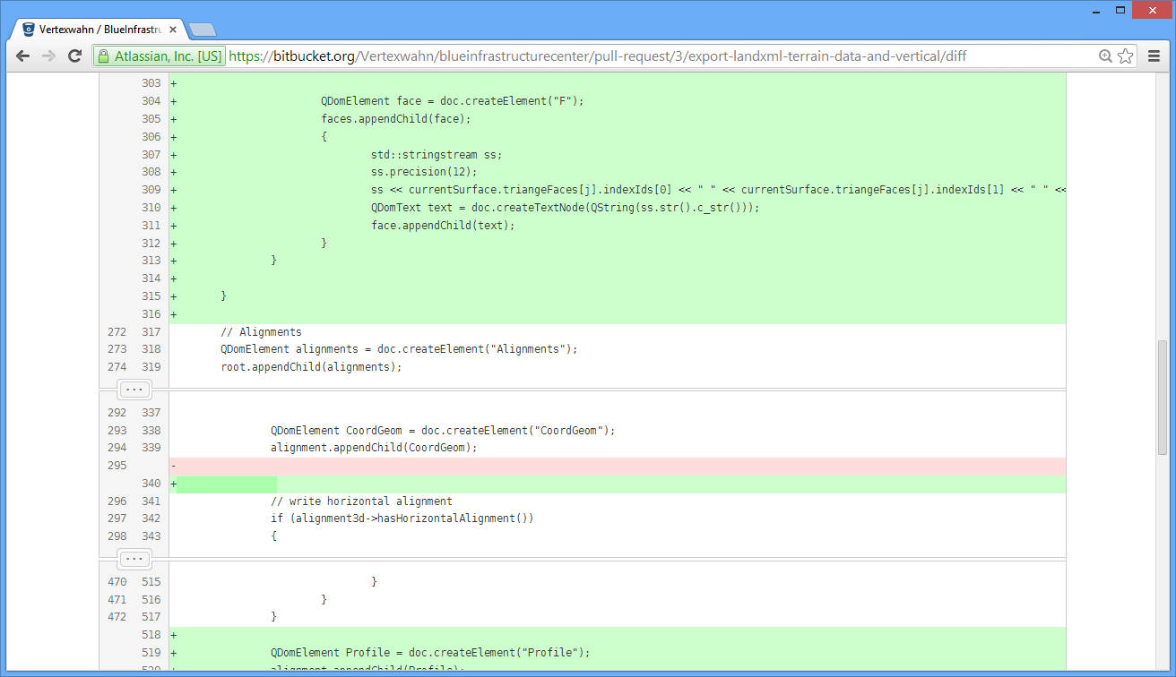

# Contacts

## The Developers

**Project Managers:**  
Julian Amann aka Vertexwahn ([julian.amann@tum.de](mailto:julian.amann@tum.de); [vertexwahn@gmx.de](mailto:vertexwahn@gmx.de))

**Current Development Team**Fabian Schöttl ([fabi-schoettl@hotmail.de](mailto:fabi-schoettl@hotmail.de))  
Helge Hecht ([helge.hecht@tum.de](mailto:helge.hecht@tum.de))

**Former Lead Test Engineer/Lead User Experience Engineer:**   
Javier Jubierre ([jubierre@bv.tum.de](mailto:jubierre@bv.tum.de))

**Former project managers:**

Dominic Singer ([dominic.singer@tum.de](mailto:dominic.singer@tum.de))Fabian Ritter ([mail@redinkinc.de](mailto:mail@redinkinc.de))

**Former developers:**Alexander Widner ([ga96heq@mytum.de](mailto:ga96heq@mytum.de); [alexander.widner@rwth-aachen.de](mailto:alexander.widner@rwth-aachen.de))  
Michael Kern aka mchke89 ([kernm@in.tum.de](mailto:kernm@in.tum.de))  
Daniel Below aka Ancaria ([daniel.below@tum.de](mailto:daniel.below@tum.de); [dbelow@hotmail.de](mailto:dbelow@hotmail.de))  
Patrick Geisler ([geisler.patrick@gmx.de](mailto:geisler.patrick@gmx.de))Nishant Gupta ([nishant.gupta@tum.de](mailto:nishant.gupta@tum.de), [nishant8568@gmail.com](mailto:nishant8568@gmail.com))  
Ahmed Mustafa ([ahmed.mustafa@tum.de](mailto:ahmed.mustafa@tum.de))

# Website

The official website can be found here:

<http://www.cms.bgu.tum.de/oip> (redirects to <https://www.cms.bgu.tum.de/de/forschung/projekte/oip>)

Also

<https://www.cms.bgu.tum.de/de/forschung/projekte/31-forschung/projekte/397-tum-open-infra-platform>

works, but is very ugly.

Short URL: <http://go.tum.de/309508>

We should try to get a better/easier URL such as <http://oip.cms.bgu.tum.de> or http://www.oip.de

This Website is for End Users of Open Infra Platform.

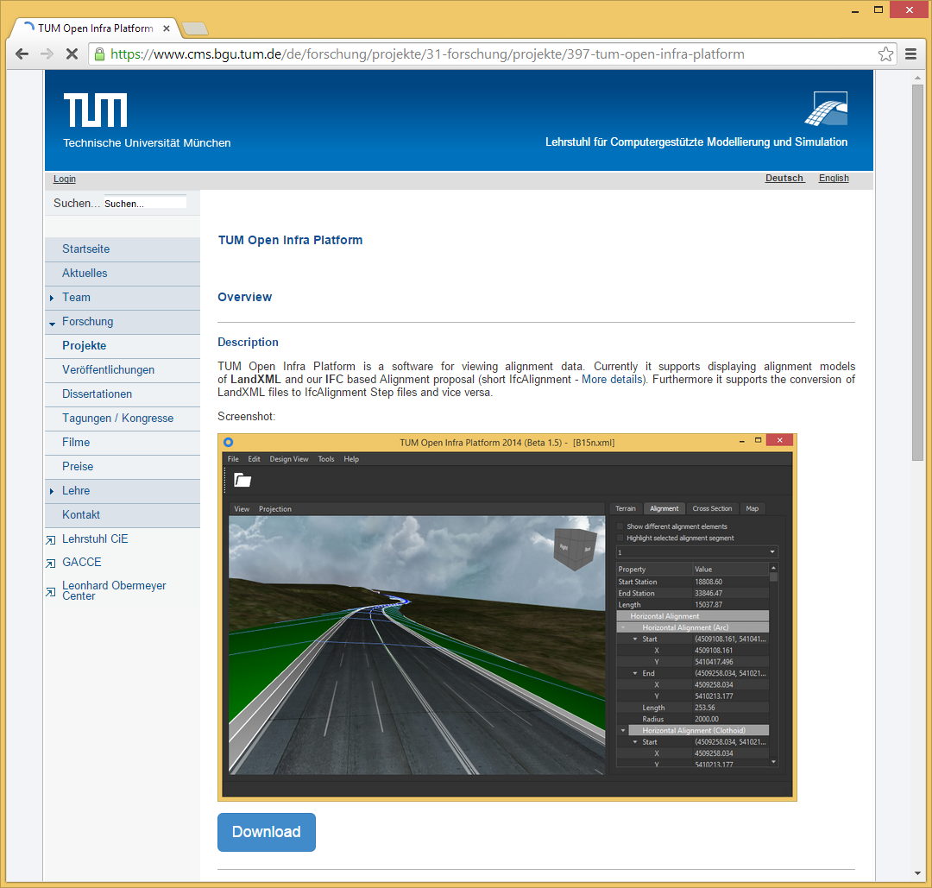

Figure 1: Website of TUM Open Infra Platform

**QR code for website:**



# TUM Open Infra Platform

## Use Cases

The following use cases should give you a small preview of the feature set of OIP.

### Use Case #1: Viewing alignment, road and terrain data

### Use Case #2: Import/Export LandXML, OKSTRA and IFC Alignment data

**Description:** A user wants to view LandXML Data.   
**Goal:** It should be possible to display LandXML data, including alignment data, digital elevation model and cross sections.  
**Actors:** Civil engineer.  
**Stakeholders:**

1. User wants to view the LandXML data in a graphical representation.

**Basic Course:**

1. We have an existing LandXML file that contains alignment data and a digital elevation model
2. A user selects the corresponding LandXML file and view it via the application

### Use Case #3: Create new alignment and terrain data

**Description:** A user wants to create an alignment and store it as an LandXML file or a user wants to import a XYZ file

## Features

Feature: IFC Alignment Export

Feature: LandXML Import

Feature: Excel Export

Feature: IFC Alignment Import

Feature: OKSTRA Import

Feature: OKSTRA Export

Feature: IFC Alignment Export

Feature: IFC Alignment Import

# Background knowledge

## Alignment

The core of each infrastructure project is its alignment. In this section different existing product models for alignment data are investigated.

## Horizontal Alignment

The horizontal alignment consists of lines, arcs and clothoids.

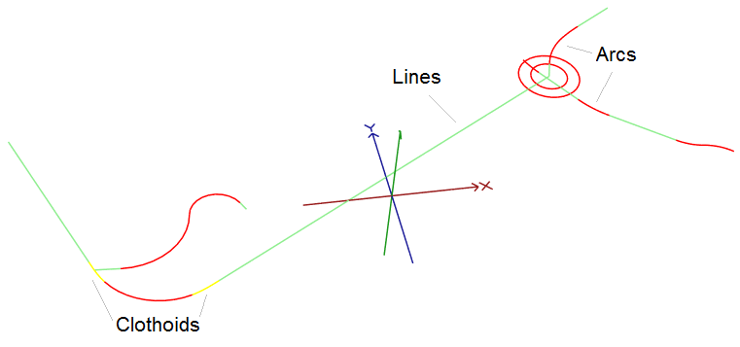

A line segment can be described by different properties. For instance line properties could be a start point, end point, length, direction, etc. The same is true for arcs and transition curves like clothoids.

|  |  |
| --- | --- |
| Semantic Property Identifier & type | Description |
| Line.Start : vector2d | Start point (x,y) of a line segement. |
| Line.End : vector2d | End point (x,y) of a line segement. |
| Line.Direction: vector2d | Direction of a line segment (Direction = End – Start) |
| Line.Length : double | Length of a line segement. |
| Arc.Center : vector2d |  |
| Arc.Start : vector2d |  |
| Arc.End : vector2d |  |
| Arc.Radius : double |  |
| Arc.Curvature : double |  |
| Arc.Length : double |  |
| Arc.Clockwise : bool |  |
| Arc.counterclockwise : bool |  |
| Arc.direction : double |  |
| Clothoid.StartRadius : double |  |
| Clothoid.EndRadius : double |  |
| Clothoid.StartCurvature : double |  |
| Clothoid.EndCurvature : double | End curvature of clothoid. |
| Clothoid.Lenght : double | Length of clothoid segment. |
| Clothoid.Constant : double | Clothoid constant value. |
| Clothoid.StartDirection : double | Start Direction |

## LandXML

### File format issues

Fixed in LandXML 1.2 schema line 1061. From <xs:complexType name="PointType" mixed="true"> to <xs:complexType name="PointType" mixed="false">. Otherwise this error occurs:

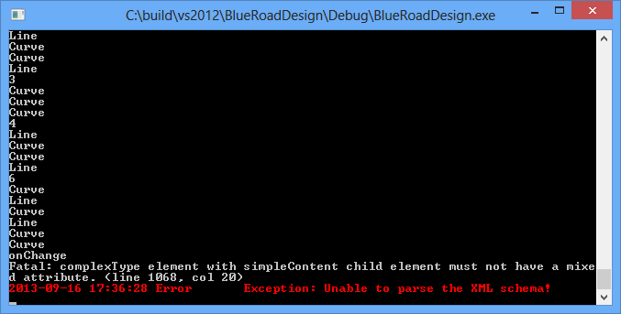

For more details see this website:

<http://www.w3schools.com/schema/schema_complex_mixed.asp>

A mixed complex type element can contain attributes, elements, and text.

**Complex Types with Mixed Content**

An XML element, "letter", that contains both text and other elements:

<letter>  
  Dear Mr.<name>John Smith</name>.  
  Your order <orderid>1032</orderid>  
  will be shipped on <shipdate>2001-07-13</shipdate>.  
</letter>

The following schema declares the "letter" element:

<xs:element name="letter">  
  <xs:complexType mixed="true">  
    <xs:sequence>  
      <xs:element name="name" type="xs:string"/>  
      <xs:element name="orderid" type="xs:positiveInteger"/>  
      <xs:element name="shipdate" type="xs:date"/>  
    </xs:sequence>  
  </xs:complexType>  
</xs:element>

**Note:** To enable character data to appear between the child-elements of "letter", the mixed attribute must be set to "true". The <xs:sequence> tag means that the elements defined (name, orderid and shipdate) must appear in that order inside a "letter" element.

We could also give the complexType element a name, and let the "letter" element have a type attribute that refers to the name of the complexType (if you use this method, several elements can refer to the same complex type):

<xs:element name="letter" type="lettertype"/>  
  
<xs:complexType name="lettertype" mixed="true">  
  <xs:sequence>  
    <xs:element name="name" type="xs:string"/>  
    <xs:element name="orderid" type="xs:positiveInteger"/>  
    <xs:element name="shipdate" type="xs:date"/>  
  </xs:sequence>  
</xs:complexType>

Spelling mistake: Weiner Bogen -> wiener bogen

### Clothoid



### Clothoid implementation

For simple cases e.g. clothoid begins or ends with curvature=0 the implementation is very easy. But implementing an arbitrary clothoid takes a bit more effort. Therefore this short tutorial helps to understand the magic behind the implementation. For the TUM Open Infra Platform the clothoid class has to deliver a getPosition(double lerpParameter) method. The instances are constructed out of the LandXML spiral element parameters.

Input parameters from LandXML:

start, end, pi (point of intersection = intersection of start- and end tangents), length, radiusStart, radiusEnd, clockwise/counterclockwise (cw/ccw)

Some general formulas for clothoids ($R_{1}>R_{2}$):

radiusStart: $R_{1}$

radiusEnd: $R_{2}$

startCurvature: $C_{1}=\frac{1}{R_{1}}$

endCurvature: $C_{2}=\frac{1}{R_{2}}$

$$A^{2}=R∙L$$

$$L=\frac{A^{2}}{R}=A^{2}∙\left(\frac{1}{R_{2}}-\frac{1}{R_{1}}\right)=A^{2}∙\left(C_{2}-C_{1}\right)$$

Calculate clothoid constant from LandXML input parameters:

$$A=\sqrt{R∙L}= \sqrt{\frac{L}{\frac{1}{R_{2}}-\frac{1}{R_{1}}}}= \sqrt{\frac{L}{C_{2}-C_{1}}}$$

Calculate lengths at $R_{1}$ and $R_{2}$:

clothoid length: $L=L_{2}-L_{1}$

length at $R_{1}$: $L_{1}= \frac{A^{2}}{R_{1}}$

length at $R_{2}$: $L_{2}= \frac{A^{2}}{R_{2}}$

How to compute local x, y coordinates at a given Length with Fresnel integrals:

$$x=\int_{0}^{L}{\cos{\frac{L^{2}}{2∙A^{2}} dL}}=…=$$

$$=L-\frac{L^{5}}{40∙A^{4}}+\frac{L^{9}}{3456∙A^{8}}-\frac{L^{13}}{599040∙A^{12}}+\frac{L^{17}}{175472640∙A^{16}}-+…$$

$$y=\int_{0}^{L}{\sin{\frac{L^{2}}{2∙A^{2}} dL}}=…=$$

$$=\frac{L^{3}}{6∙A^{2}}+\frac{L^{7}}{336∙A^{6}}-\frac{L^{11}}{42240∙A^{10}}+\frac{L^{15}}{9676800∙A^{14}}-+…$$

How to compute global x, y coordinates at a given interpolation parameter

1. Calculate length at given interpolation parameter by interpolating between L1 and L2
2. Calculate offset x, y, coordinates at L1
3. Calculate deltaX and deltaY by calculating x, y coordinates at interpolation length(1.) and subtract the offset values
4. Calculate rotation angle between local and global coordinate system and rotate coordinates by this angle
5. Translate local system to global system by vector startgobal-startlocal



Future work: Convert in the minimum parameter Schema of RoadXML.

### Vertical alignment

A vertical alignment is described in LandXML by ProfAlign. LandXML does not store the start (green points) and end point (yellow points) of a parabola element. Instead it stores a so called PVI (point of vertical intersection, blue color). Besides the PVI also a length value is stored for each parabola. From the length value and the PVI the start and end point can be computed.

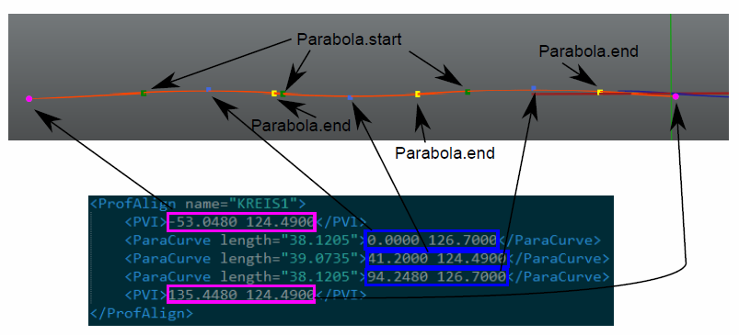

### Computation of vertical alignments (parabolas)

$M\left(-50,75\right)=M(x_{1},y_{1})$; $N\left(50,50\right)=N(x_{2},y_{2})$; $m_{1}=0,5$, $m_{2}=-1$

$f\left(x\right)=ax^{2}+bx+c$; $f'\left(x\right)=2ax+b$

$${I:m}_{1}=2ax_{1}+b$$

$$II:m_{2}=2ax_{2}+b$$

I nach b: $${b=m}_{1}-2ax_{1}=m_{2}-2ax_{2}$$

I in II:

$$m_{2}=2ax_{2}+m_{1}-2ax_{1}$$

$$m_{2}-m_{1}=2a\left(x_{2}-x_{1}\right)$$

$$\frac{m_{2}-m_{1}}{x_{2}-x_{1}}=2a$$

$$a=0,5\frac{m_{2}-m_{1}}{x_{2}-x_{1}}$$

a=-0,0075

$${b=m}_{2}-2ax_{2}=-1-2*\left(-0,0075\right)*50=-1+0,75= -0,25$$

### Vertical alignment that starts with a parabola

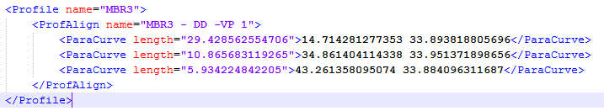

This is an invalid vertical alignment. Depending on the first tangent the red intersection point can be placed on different locations.

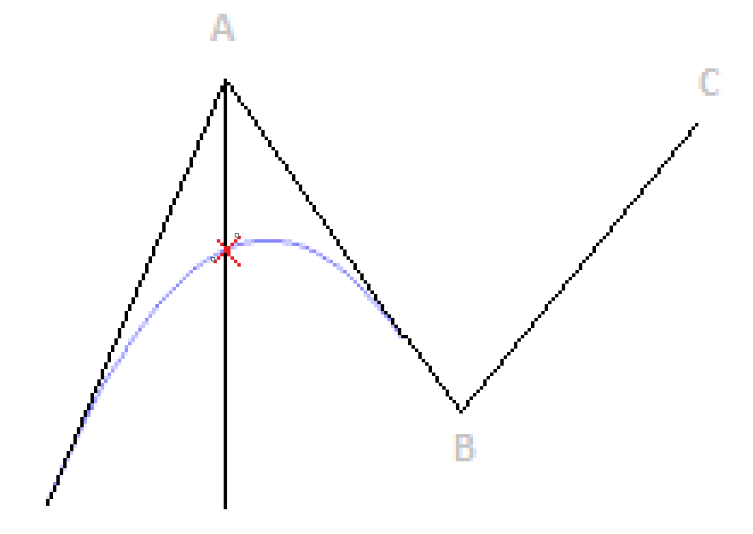

## IFC Alignment

Hier gilt die „dependent definition“ (untere Reihe) – das heißt das Attribut „IsCcw“ der Klothoide ist “start/end point dependent” und nicht “start/end point independent”

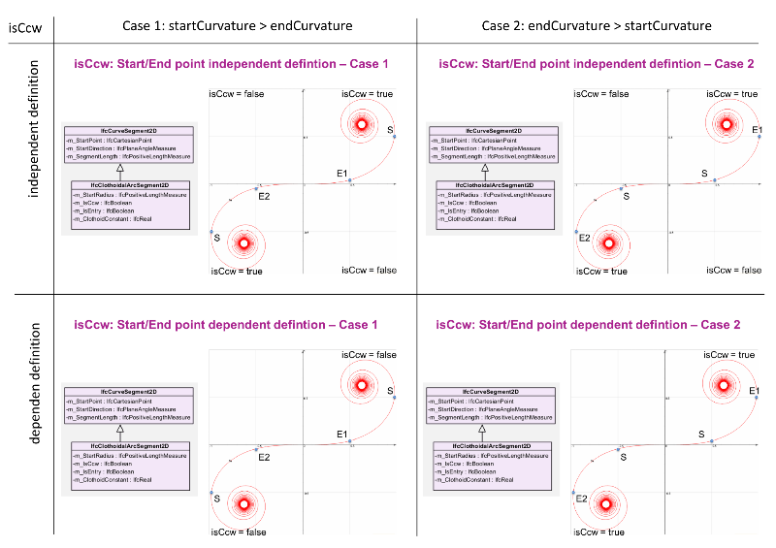

## RoadXML

RoadXML is an open file format for the logical description of road networks (<http://www.road-xml.org/>). It is used most frequently in traffic and driving simulations. RoadXML provides a data structure for tracks. A Track consist of a XYCurve and a SZCurve. The XYCurve describes the horizontal alignment of track and the SZCurve the vertical alignment.

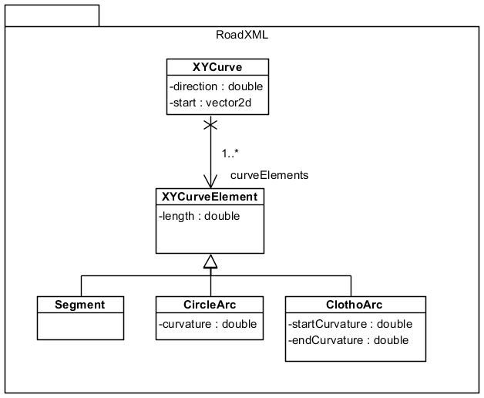

Figure 1: A XYCurve in RoadXML consist of staight lines (segment), circle arc and clothids (ClothoArcs).

<Track endNode="Intersection" name="Track 3" startNode="Intersection 2">

<XYCurve direction="1.75917" x="50.0104" y="-83.2074">

<ClothoArc endCurvature="0" length="8.009" startCurvature="-0.0309793"/>

<ClothoArc endCurvature="0" length="3.51943" startCurvature="0.0143293"/>

<CircleArc curvature="0.00105004" length="128.811"/>

<Segment length="2.7"/>

</XYCurve>

The direction specified in the <XYCurve> tag is the initial direction of the curve (in radians, 0 is pointing along the x axis: east, positive counter clockwise). The x and y values are the initial position of the curve, in meters.

The circle arc starts in the direction and position specified in the <XYCurve> tag and has the specified curvature and length. Note that if you add another <CircleArc> tag after the first one, the initial position and direction of the following one will be the final positon/direction of the previous one [Mail from Hello Hewat].

## Tools

### JSDAI

For editing EXPRESS Schemas the tool JSDAI for Eclipse (<http://www.jsdai.net/eclipse>) can be used.

It provides a graphical editor for viewing EXPRESS diagrams (EXPRESS-G):

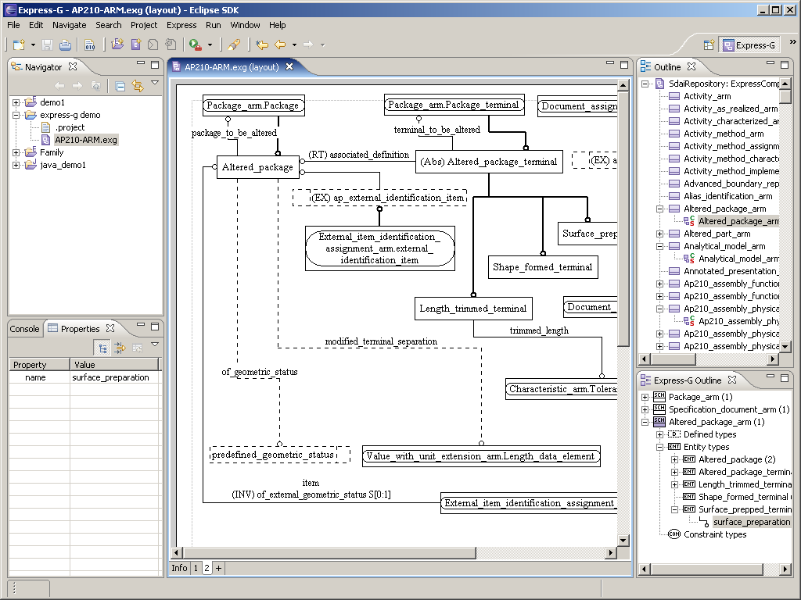

The tool can also validate the syntax of an express schema.

Moreover JSDAI provides an SDAI API for Java that enables Java developers to read and write step files for a given express schema.

### AutoCAD Civil 3D 2014

AutoCAD Civil 3D 2014 is a BIM tool for civil engineering (<http://www.autodesk.com/products/autodesk-autocad-civil-3d/features/all/gallery-view>)

Students can acquire a free license from <http://www.autodesk.com/education/student-software>. Just setup an account. Afterwards you have free access to all Autodesk products (including 3ds max, Maya, AutoCAD Civil 3D 2014 and many more).

AutoCAD Civil3D 2014 can import LandXML files.

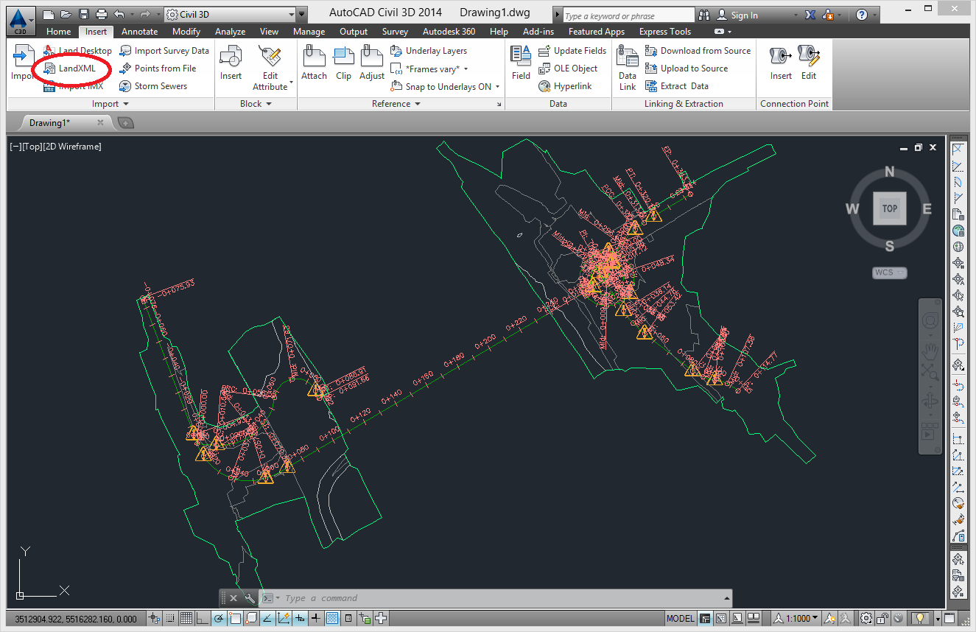

# Code Guidelines

## Syntax #1

Use nullptr instead of NULL.

## Ident style #1

Use Allman style.

int OpenInfraPlatform::DataManagement::IfcZipper::writeLocalFileHeader(localzipheader* header) {

if (!ofs.is_open()) {

BLUE_LOG_STREAM_EX("IfcZip Export", buw::eLogSeverityLevel::Error) << "Output filestream is closed";

return -1;

}

if (header == NULL) {

BLUE_LOG_STREAM_EX("IfcZip Export", buw::eLogSeverityLevel::Error) << "header is null";

return -2;

}

ofs.write((char*)header, 14);

ofs.write((char*) &header->crc32, 16);

int pos = filename.toStdString().find_last_of('/', filename.size()) + 1;

ofs.write(filename.toStdString().substr(pos,header->fileNameLength).data(), header->fileNameLength);

return 0;

}

Should be:

int OpenInfraPlatform::DataManagement::IfcZipper::writeLocalFileHeader(localzipheader* header)

{

if (!ofs.is_open())

{

BLUE_LOG_STREAM_EX("IfcZip Export", buw::eLogSeverityLevel::Error) << "Output filestream is closed";

return -1;

}

if (header == NULL)

{

BLUE_LOG_STREAM_EX("IfcZip Export", buw::eLogSeverityLevel::Error) << "header is null";

return -2;

}

ofs.write((char*)header, 14);

ofs.write((char*) &header->crc32, 16);

int pos = filename.toStdString().find_last_of('/', filename.size()) + 1;

ofs.write(filename.toStdString().substr(pos,header->fileNameLength).data(), header->fileNameLength);

return 0;

}

## Comments #1

Write comments in English language – do not use another language!

// Schreibt den übergebenen File Header in die Datei

should be:

// Stores the given file header in the file

## Comments #2

Use a space to spate the comment introduction in single-line comment form the real comment.

//Stores the given file header in the file

Should be:

// Stores the given file header in the file

## Tags

Each source file should have the following header:

/*! \verbatim

* \copyright Copyright (c) 2015 Technische Universität München

* Chair of Computational Modeling and Simulation. All rights reserved.

* \author Fabian Schöttl <fabian.schoettl@tum.de> (https://www.cms.bgu.tum.de/en/)

* \author Julian Amann <julian.amann@tum.de> (https://www.cms.bgu.tum.de/en/team/amann)

* \author Dominic Singer <dominic.singer@tum.de> (https://www.cms.bgu.tum.de/de/team/singer)

* \brief This file is part of the TUM Open Infra Platform.

* \endverbatim

*/

See also “OpenInfraPlatform\docs\tag.txt” file. Use the same formatting as is used in the “tag.txt” file.

Add your name to the author list if you have contributed to the corresponding file. Try to sort the author list by contribution. If you have made the main contribution to a file your name should be listed first.

## Includes #1

Use „/“ instead of „\“.

#include "BlueFramework/Infrastructure/Alignment/Alignment2DBased3D.h" // correct!

#include "BlueFramework\Infrastructure\AlignmentModel\AlignmentModel.h" // wrong!

## Includes #2

Do not use .. for a relative path in an include file. When moving source files this path names get invalid. Forthermore it is difficualt to figure out where a file is exactly located and how it is related to the other include files.

#include "../Benchmark.h" // wrong!

#include "OpenInfraPlatform/Benchmark.h" // correct!

## CMake

Use lower case characters, because they are easier to type and modify. So instead of

PROJECT(BlueFramework.Infrastructure)

Use:

project(BlueFramework.Infrastructure)

Also mixed lower and upper case looks strange. Stick to one.

# Code Architecture

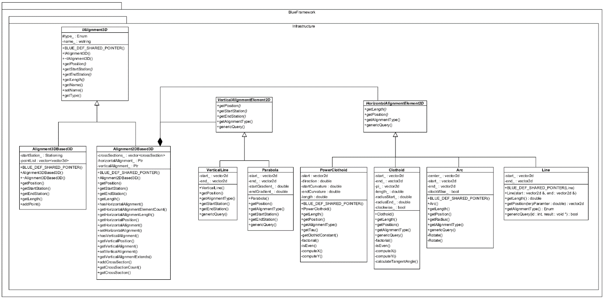

There are two types of alignments – a 3D based one – and a 2D based one. A 2D based one consists of a vertical alignment and a horizontal alignment. A horizontal alignment consist of horizontal alignment elements such as PowerClothoid, Arc or Line. A line consist of a start and an end point.

# Code in Detail

## IFC Eearly Binding Meta Template Library (ifcEMT)

wir sollten eine Art IFC Eearly Binding Meta Template Library (ifcEMT) entwickeln

Für jeden Entity Typ wird ein Template Parameter generiert – etwa so:

namespace BlueFramework

{

       namespace Ifc2x3

       {

             class IfcFace;

             ...

       }

}

namespace emt

{

       template <

             typename IfcFaceTypeType

             ...

       >

       struct IfcEntityTypes

       {

             typedef IfcFaceTypeType IfcFace;

             ...

       };

       typedef IfcEntityTypes<

BlueFramework::Ifc2x3::IfcFace

...

>

Ifc2x3EntityTypes;

       typedef IfcEntityTypes<

BlueFramework::Ifc4::IfcFace

...

>

Ifc4EntityTypes;

}

Am Schluss haben wir dann einfach ein Template mit ca. 600 Template Parametern - ist auch schon eingecheckt – siehe EMTIfcEntityTypes.h, EMTIfc2x3EntityTypes.h, EMTIfc4EntityTypes.

Ich habe begonnen aus dem FaceConverter ein Template zu machen:

             template <

                    class IfcEntityTypesT,

                    class IfcUnitConverterT

             >

             class FaceConverterT

Ähnlich bin ich beim PlacementConverter vorgegangen:

template <

                    class IfcEntityTypesT

             >

             class PlacementConverterT

             {

Zum Testen benutze ich den FaceConverterT in der Methode convertIfcSurface der Klasse FaceConverter.

                    void convertIfcSurface(const shared_ptr<OpenInfraPlatform::Ifc2x3::IfcSurface>& surface,

                           const carve::math::Matrix& pos,

                           shared_ptr<carve::input::PolylineSetData>& polyline_data)

                    {

                           FaceConverterT<emt::Ifc2x3EntityTypes, OpenInfraPlatform::Ifc2x3::UnitConverter> f(

m_geom_settings, m_unit_converter, m_curve_converter);

                           f.convertIfcSurface(surface, pos, polyline_data);

                           return;

Kannst du das Template FaceConverterT noch vollständig implementieren und testen?

Kannst du außerdem noch das PlacmentConvertT Template vollständig implementieren?

Im Prinzip muss dabei nur jedes vorkommen eine IFC Entity Typs ersetzt werden – etwa so:

IfcPlacement

->

typename IfcEntityTypesT::IfcPlacement

Soweit ich das jetzt überblicke müssen noch folgende Klassen in Templates umgewandelt werden (genau in dieser Reihenfolge):

CurveConverter

ProfileCache

ProfileConverter

RepresentationConverter

SectionedSpine

SolidModelConverter

StylesConverter

IfcImporter

BlueFramework.Viewport anbieten

# Testing

## Testdata

testdata\CityCad\Sito_Tie.xml

Autodesk Civil 3D cannot handle this file:

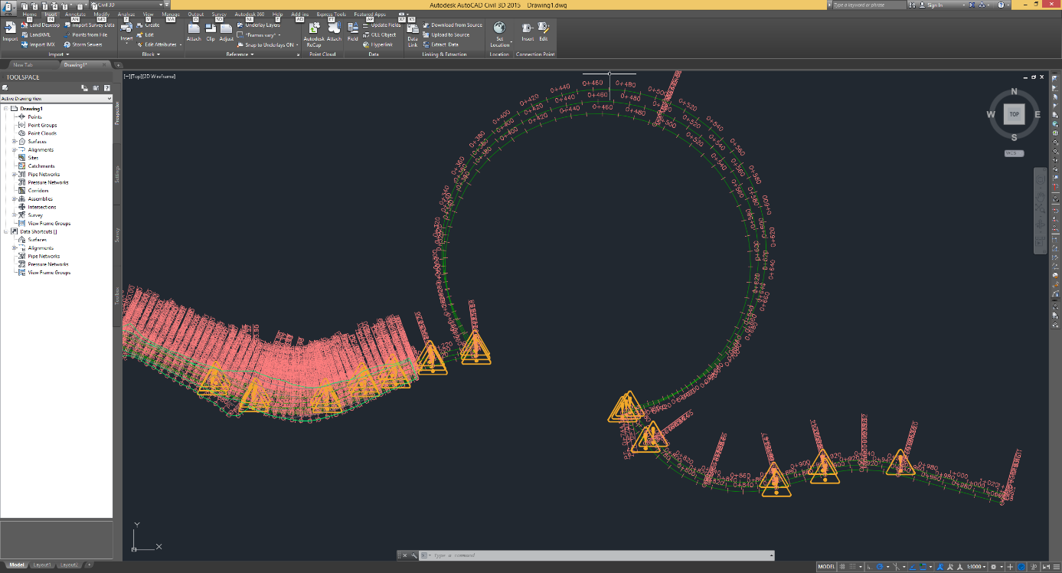

When trying to improting this file to OIP we detected that we are not able to compute the end point of the following clothoid:

<?xml version="1.0" encoding="ISO-8859-1" standalone="yes"?>

<LandXML xmlns:xsi="http://www.w3.org/2001/XMLSchema-instance" xsi:schemaLocation="http://www.inframodel.fi/inframodel http://www.inframodel.fi/schemas/2.0.9/inframodel.xsd" xmlns="http://www.inframodel.fi/inframodel" date="2013-06-05" time="16:32:35" version="1.2" language="Finnish" readOnly="false">

<Project name="InfraModel" desc="InfraModel testiaineisto" state="proposed"/>

<Units>

<Metric areaUnit="squareMeter" linearUnit="meter" volumeUnit="cubicMeter" temperatureUnit="celsius" pressureUnit="mmHG" directionUnit="grads" angularUnit="grads" diameterUnit="meter" widthUnit="meter" heightUnit="meter" velocityUnit="kilometersPerHour" />

</Units>

<CoordinateSystem horizontalCoordinateSystemName="KKJ" verticalCoordinateSystemName="N60" desc="National Land Survey Finland " rotationAngle="0" />

<Application name="CityCad" manufacturer="Sito" manufacturerURL="http://www.sito.fi" version="5" timeStamp="2013-06-05T16:32:35">

<Author createdBy="matti.heikkila" timeStamp="2013-06-05T16:32:35" company="Sito" companyURL="http://www.sito.fi" />

</Application>

<Alignments name="MT301" desc="Inframodel3">

<Alignment name="Mittalinja" oID="5363" staStart="0" length="25.6000000000951" state="proposed">

<CoordGeom>

<Spiral length="25.6000000000951" radiusEnd="INF" radiusStart="90" rot="ccw" spiType="clothoid" constant="48.0000000000891" dirEnd="76.0074731892313" dirStart="85.0616210292649" staStart="141.788351337172">

<Start>6677640.57582574 2546177.99634336 0</Start>

<PI>6677644.56796775 2546190.1400906 0.0</PI>

<End>6677648.8511542 2546202.19761461 0</End>

</Spiral>

</CoordGeom>

<Profile staStart="0">

<ProfAlign name="0">

<PVI>0 1</PVI>

<PVI>25.6000000000951 1</PVI>

</ProfAlign>

</Profile>

</Alignment>

</Alignments>

</LandXML>

It seems the provided data is invalid. Maybe this is because of an export error in CityCad.

## Unit Testing

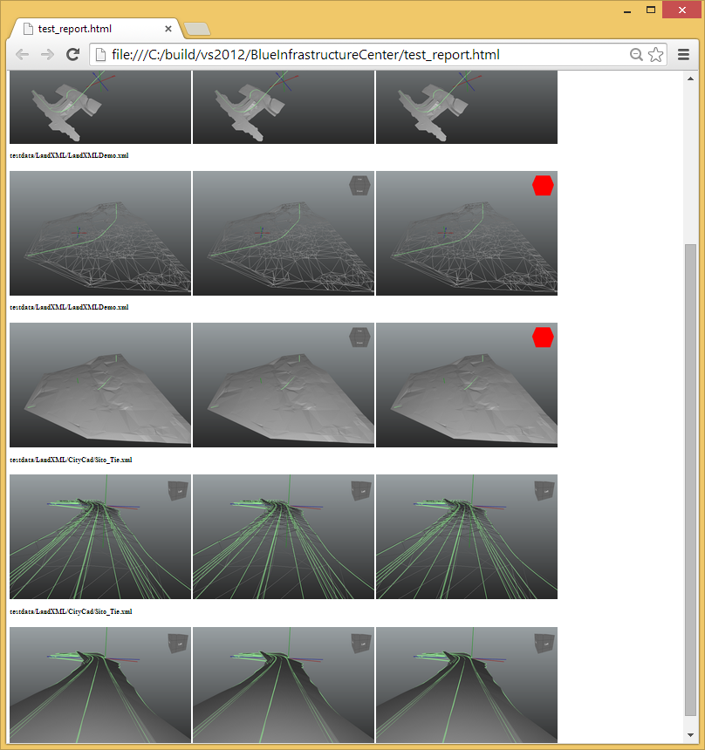

## IFC Alignment Common Mistakes

### Check #1

Fehlende GUIDs (z.B. in vertical_alignment.ifc)

#23=IFCALIGNMENT($,$,$,'test',$,$,$,$,#24,#34,$);

GUID ist kein optionales Attribut und sollte daher gesetzt werden

### Check #2

RelatedElements mindestens SET [1:?] (z.B. vertical_alignment.ifc)

#20=IFCRELCONTAINEDINSPATIALSTRUCTURE('09AjNQa69Dlv5Mt8ZRJ1R3',$,$,$,$,#16);

### Check #3

NaN Werte (z.B. terrain-and-alignment.ifc)

#102=IFCALIGNMENT2DVERSEGLINE($,$,$,265.65600000000001,0,125.815,-1.#IND);

### Check #4

INTEGER anstatt DOUBLE – einige EXPRESS-Parser sind da ganz genau (z.B. vertical_alignment.ifc)

#29=IFCCLOTHOIDALARCSEGMENT2D(#30,5.7380475130104633,77.500241000000003,500,.T.,.T.,326.99697894146078);